End-to-End Supply Chain Analytics Report
Project Overview
The objective of this project was to analyze a supply chain dataset and identify the major factors affecting delivery performance, profitability, inventory management, and customer satisfaction. Data cleaning, exploratory data analysis (EDA), KPI analysis, bottleneck detection, and root cause analysis were performed to answer the business questions.

Business Problem
The company is facing several operational challenges:
- Frequent delayed deliveries
- High transportation costs
- Inventory stock-outs
- Overstocked warehouses
- Low supplier performance
- Demand forecasting issues
- Low customer satisfaction due to late shipments
The goal of this analysis is to identify these problems using data analytics and provide insights for business improvement.

Business Questions and Analysis
. How can delivery performance be improved?
Analysis Performed:-
- Calculated Order Processing Time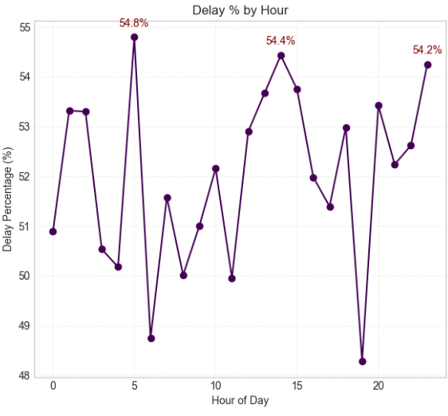

- Calculated Delivery Delay (in days)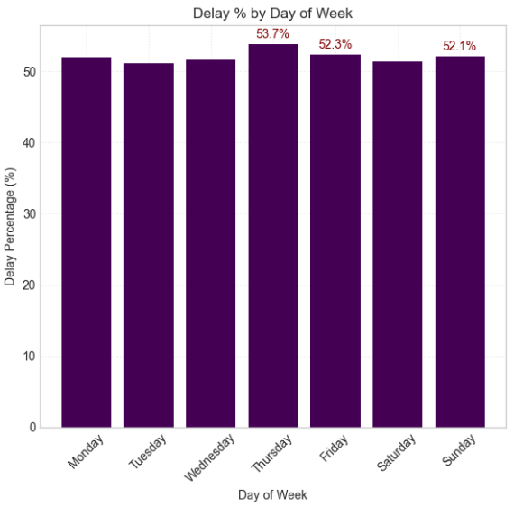
- Created Column for Delay Distribution Analysis
- 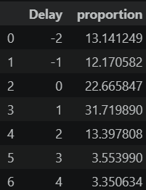
- Calculated Delay Percentage
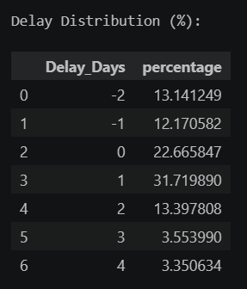
- Analyzed Delay Trend by Month, Day, and Hour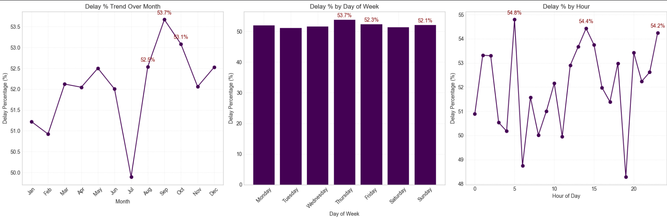

- Insights:-
- A significant percentage of orders were delivered late. 
- Certain months showed higher delay percentages, indicating seasonal demand. 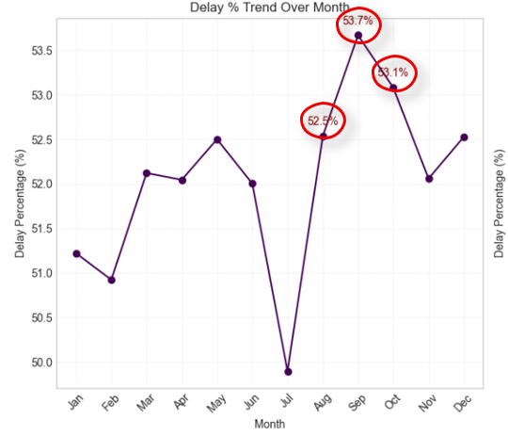
Recommendation
- Improve logistics planning during peak months.
- Optimize delivery routes.
- Increase warehouse staffing during high-demand periods
- Maintain safety stock only for fast-moving products.
- Reduce inventory levels for slow-moving items.
- Implement demand-based inventory planning.

. Which suppliers or regions are responsible for delivery delays?
Analysis Performed
- Delay Percentage by:
  - Shipping Mode 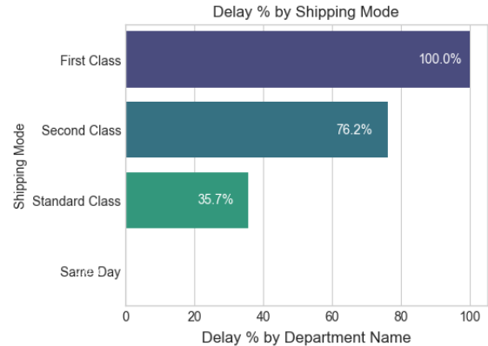
  - Customer Segment
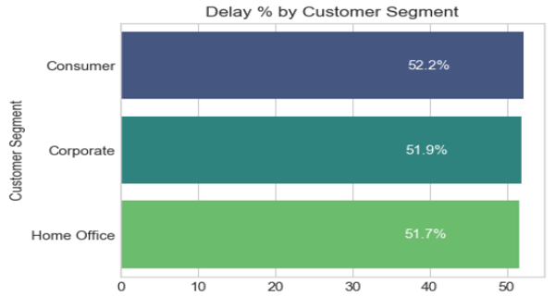
  - Department
  - 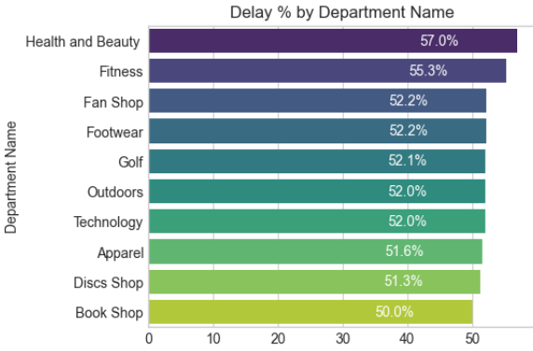
  - Order Region
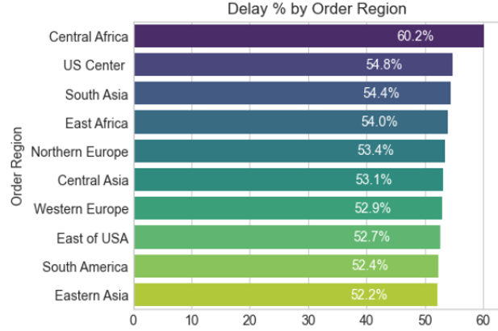
  - Order Status
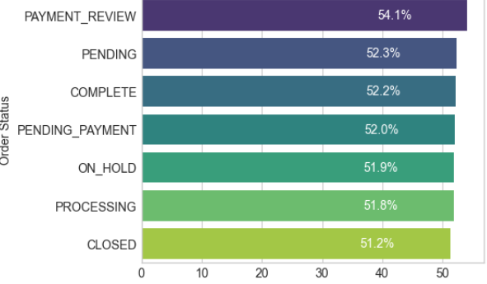

Insights
- Certain regions consistently recorded higher late-delivery percentages.
- Some shipping methods were associated with more delayed deliveries.
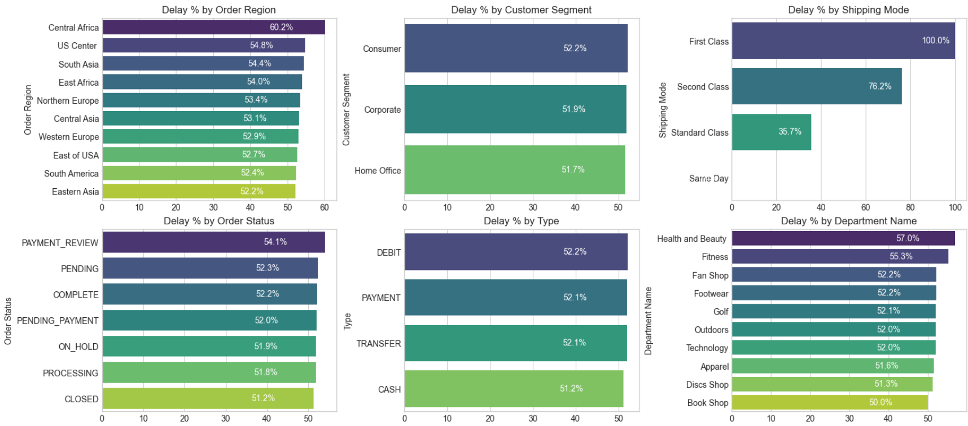
Recommendation
- Monitor supplier and logistics performance regularly.
- Review contracts with consistently underperforming suppliers.
- Improve transportation planning in high-delay regions.

Analysis Performed
Root cause analysis was performed using:
- Shipping Mode
- Order Region
- Department Name
- Customer Segment
- Order Status
Insights
- Shipping mode and regional operations were major contributors to late deliveries.
- Some customer segments experienced higher delay percentages.
Recommendation
- Improve transportation planning.
- Optimize warehouse operations.
- Introduce region-specific logistics strategies.

Key KPIs Developed
- Total Orders: 84581
- Late Deliveries: 44001
- 90% Delay (days): 3.00
- On time Delivery %: -51.02
- Late Deliveries %: 52.02
- Total Profit: 3.7M $
- Total Loss due to delays: 987.7K $

Overall Business Insights
- Delivery delay is one of the primary reasons for reduced customer satisfaction.
- Longer delivery times negatively affect profitability.
- Demand shows seasonal fluctuations, requiring better forecasting.
- Some regions consistently experience higher delivery delays.
- Inventory optimization can reduce holding costs and stock-outs.
- Monitoring logistics KPIs regularly can significantly improve supply chain performance.

Final Conclusion
This End-to-End Supply Chain Analytics project successfully identified the key operational issues affecting the company's supply chain. Through data cleaning, KPI analysis, profitability analysis, bottleneck detection, and root cause analysis, several actionable insights were generated. Implementing the recommended strategies can improve delivery performance, reduce operational costs, enhance inventory management, and increase overall customer satisfaction, resulting in a more efficient and profitable supply chain.

